Annapurna SIL Graphite features

Graphite features are used by the Graphite engine to render the proper shaping of Devanagari characters. However, some applications let the user control which features to use. Here is a list of some found in Annapurna SIL.
New (version 1.100): To conform to the CSS four-character tag requirements, Graphite feature IDs for variants of jha, kra and tra have been modified to jhav, krav and trav.
How to access Graphite features
When Annapurna SIL is used in applications that support Graphite, and that provide an appropriate user interface, various user-controllable font features are available that allow access to variant glyphs that might be preferable for use in some contexts. In LibreOffice 3.4+ and the Graphite version of OpenOffice 3.2 the font features can be turned on by choosing the font (e.g. Annapurna SIL), followed by a colon, followed by the feature ID, and then followed by the feature setting. So, for example, if the Nepali Jha alternates are desired, the font selection would be “Annapurna SIL:jhav=1”. If you wish to apply two (or more) features, you can separate them with an “&”. Thus, “Annapurna SIL:jhav=1&dig5=1” would apply Nepali “Jha alternates” plus the “Digit five alternate” features. In the charts on the next page, the first in the list is the default (0) followed by ID=1 and if available, followed by ID=2.
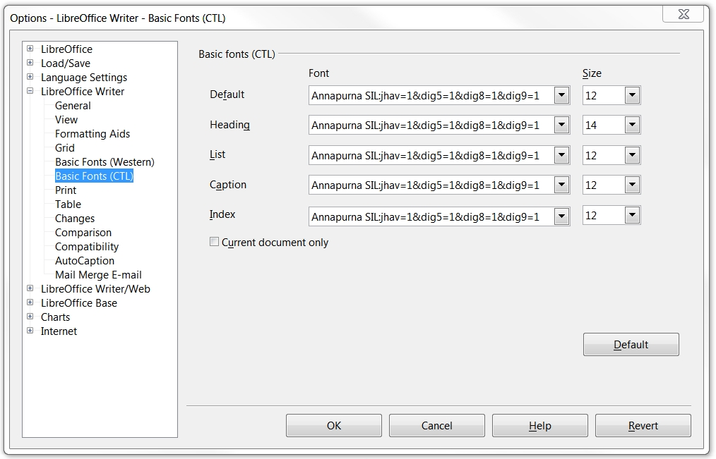

One way to do this is to choose Tools (on the menu bar) > Options > Writer > Basic Fonts (CTL) and after Annapruna SIL, type in the feature(s) desired. The illustration above enables the Nepal version of Jha alternates and digits five, eight and nine (Form 2) alternates. This method applies the features to the whole document.
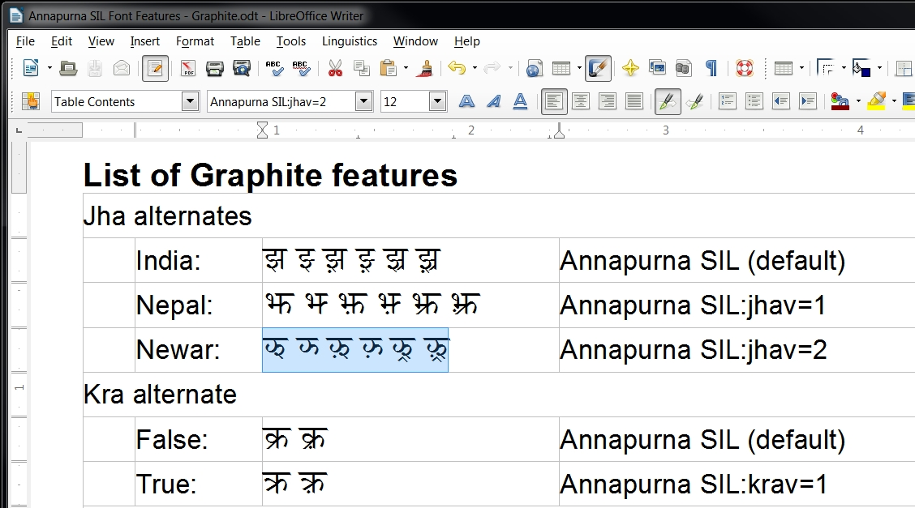

If you only want to apply the feature(s) to part of the text, select the desired text (shown circled) and then type in the desired feature ID(s) in the font box (where the arrow is pointing).
The next page gives the list of feature IDs.

List of Graphite features
Jha alternates
 | India: | झ झ्‍ झ़ झ़्‍ झ्र झ़्र | Annapurna SIL (default)
 | Nepal: | झ झ्‍ झ़ झ़्‍ झ्र झ़्र | Annapurna SIL:jhav=1
 | Newar: | झ झ्‍ झ़ झ़्‍ झ्र झ़्र | Annapurna SIL:jhav=2
Kra alternate
 | False: | क्र क़्र | Annapurna SIL (default)
 | True: | क्र क़्र | Annapurna SIL:krav=1
Tra alternate
 | False: | त्र त़्र | Annapurna SIL (default)
 | True: | त्र त़्र | Annapurna SIL:trav=1
Shra alternate
 | False: | श्र श़्र | Annapurna SIL (default)
 | True: | श्र श़्र | Annapurna SIL:shra=1
Dya and hya alternates
 | False: | द्य द्‌य्‍‌‍‍ द्य़ द्‌य़्‍ द्य्र द्य़्र  ह्य ह्य्‍ ह्य़ ह्य़्‍ ह्य्र ह्य़्र | Annapurna SIL (default)
 | True: | द्य द्‌य्‍‌‍‍ द्य़ द्‌य़्‍ द्य्र द्य़्र  ह्य ह्य्‍ ह्य़ ह्य़्‍ ह्य्र ह्य़्र | Annapurna SIL:dyah=1
Ukar nukta position
 | Inside: | कु़ कू़ क्कु़ क्कू़ | Annapurna SIL (default)
 | Outside: | कु़ कू़ क्कु़ क्कू़ | Annapurna SIL:ukar=1
Ekar nukta position
 | Low: | के़ | Annapurna SIL (default)
 | High: | के़ | Annapurna SIL:ekar=1
Digit five alternate
 | False: | ५ | Annapurna SIL (default)
 | True: | ५ | Annapurna SIL:dig5=1
Digit eight alternate
 | False: | ८ | Annapurna SIL (default)
 | True: | ८ | Annapurna SIL:dig8=1
Digit nine alternate
 | Form 1 | ९ | Annapurna SIL (default)
 | Form 2 | ९ | Annapurna SIL:dig9=1
 | Form 3 | ९ | Annapurna SIL:dig9=2
Visarga connecting bar
 | False: | ः | Annapurna SIL (default)
 | True: | ः | Annapurna SIL:vbar=1
Limbu glottal stop connecting bar
 | True: | ॽ | Annapurna SIL (default)
 | False: | ॽ | Annapurna SIL:gbar=1
Archaic forms
 | False: | अ आ ओ औ ण ण्‍ क्ष क्ष् | Annapurna SIL (default)
 | True: | अ आ ओ औ ण ण्‍ क्ष क्ष् | Annapurna SIL:arch=1

Download here: http://www.libreoffice.org/. (This application has the faster graphite2 rendering engine.)
Download here: http://www.openoffice.org/.
Either OpenOffice.org Writer or LibreOffice Writer

